**Android Training Project**

*Rhythm music player and it’s functionalities:*

1. A Splash screen (gradient background and app logo in center)

2. A Navigation drawer with app logo section at the top along with links to ‘All Songs’,

‘Favorites’, ‘Settings’ and ‘About Us’.

3. An ‘All songs’ screen (where of list all the tracks fetched from offline storage are

displayed and user can sort the tracks by name or recently added). This will the

home screen of the app.

4. The app should be able to fetch and play .mp3 and .wav files.

5. A ‘Favorites’ screen (where list of all the favorite songs are displayed)

6. A ‘Settings’ screen (where the ‘Shake to change song’ feature can be enabled or

disabled)

7. An ‘About us’ screen (where we will display information about the app developer and

the app version)

8. A ‘Now playing’ screen with following features:

a. Track title and track artist

b. Play / Pause button

c. Next button

d. Previous button

e. Shuffle button

f. Loop button

g. Seek bar

h. Mark track as favorite or unfavorite it

i. Third party visualizer in upper half background

j. A ‘Back to list’ button in the header which should take the user to the screen

he came from (kind of like back button behavior).

k. Shake to change song

9. A ‘Now playing’ bar at the bottom with name of the track playing and play or pause

feature. This would appear if the user has moved from ‘Now playing’ screen to ‘All

songs’ screen or ‘Favorites’ screen without pausing the track.

10. Background play. The app will continue playing the track if the app gets closed (not

killed) without the music being paused.

11. A notification saying "A track is playing in the background" only if the app gets closed

(not killed) without the music being paused.

**Primary Color scheme:** #9b2a58, #00032a

**SPECIFICATIONS:**

***Splash screen***

This would be the first screen that gets displayed when a user opens the app. It would have

a linear gradient background and the app logo in the center of the screen. The user will see

the screen for 1 second and then the home screen will pop up.

**Resources:**

Gradient hex-color codes: #9b2a58, #00032a

App logo: Rhythm

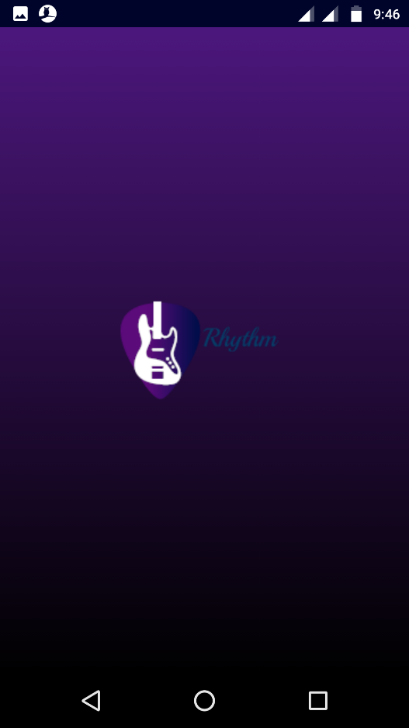

***Navigation drawer***

The navigation drawer is needed so that the user can navigate to different screens within the

app. The user should be able to access the navigation drawer on all the app screens by

clicking hamburger button on the left side of the header or by swiping right from the left

edge. It would have an app logo section at the top with gradient in the background and app

logo in center (similar to Splash screen but smaller). Below the app logo section, there would

links to ‘All songs’, ‘Favorites’, ‘Settings’ and ‘About us’ screen in a list style. Clicking on any

link will open the corresponding screen.

**Resources:**

Gradient hex-color codes: #9b2a58, #00032a

App logo: Rhythm_logo

‘All songs’ icon: navigation all songs

‘All songs’ color: #212121

‘Favorites’ icon: navigation favorites

‘Favorites’ color: #212121

‘Settings’ icon: navigation settings

‘Settings’ color: #212121

‘About us’ Icon: navigation about us

‘About us’ color: #212121

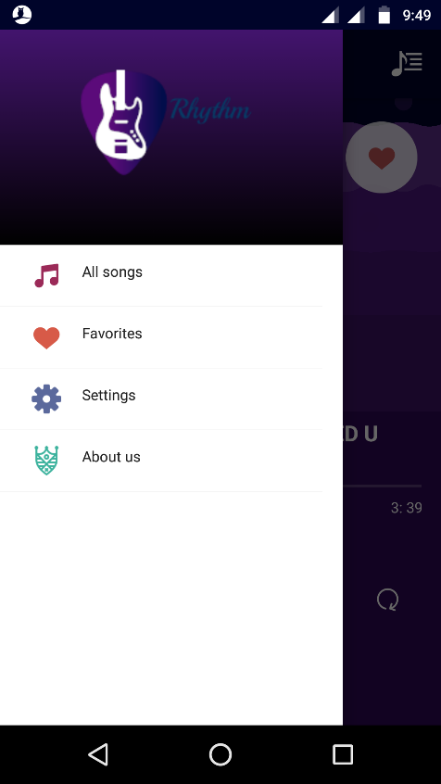

**‘*All songs’ screen***

‘All songs’ screen will be the home screen of the app, meaning when the app is launched,

user will see the ‘All songs’ screen after the splash screen.

Once the app is launched, all the tracks (.mp3 and .wav) will be fetched from the offline

storage and will be displayed on the ‘All songs’ screen in a list view. By default, all the tracks

would be sorted by name. For each track in the list, the user should see the title of the track

and the artist of the track. If there is no title, the track name will be displayed in place of the

title. If there is no artist, ‘unknown’ will be displayed in place of the artist. There would also

be a line separating each track.

When the user clicks on any track, the ‘Now playing’ screen should open and the track

should start to play.

**Resources:**

Track title hex color code: #212121

Track artist hex color code: #bdbdbd

**Sort feature:**

The ‘All songs’ screen will have a Sort feature. Using the Sort feature, the user should be

able to sort the tracks by name or by recently added. A sort icon will be there on the right

side of the header, when clicked on, then a dropdown will appear with two options:

1. By recently added

2. By name

If the user clicks on ‘By recently added’, all the tracks would get sorted by recency with most

recently added track on the top. ‘By name’, all the tracks would get sorted in alphabetical

order (or in this order: track title starting with symbols, track title starting with numbers and

then track title starting with letters).

**Resources:**

Sort icon: sort icon

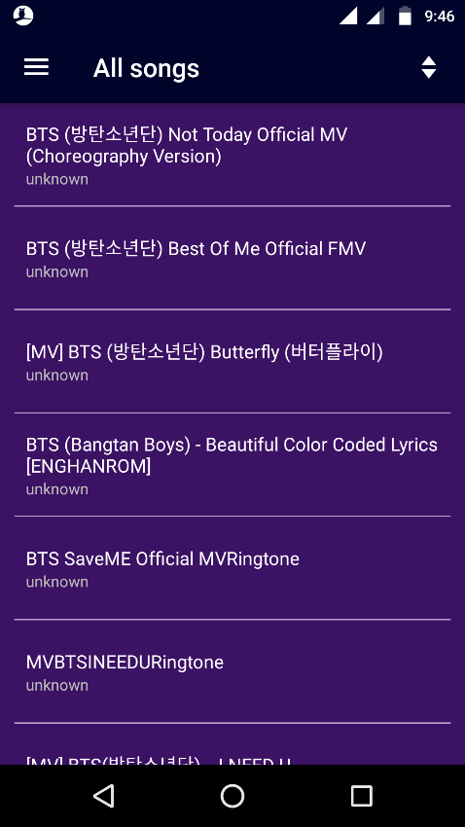 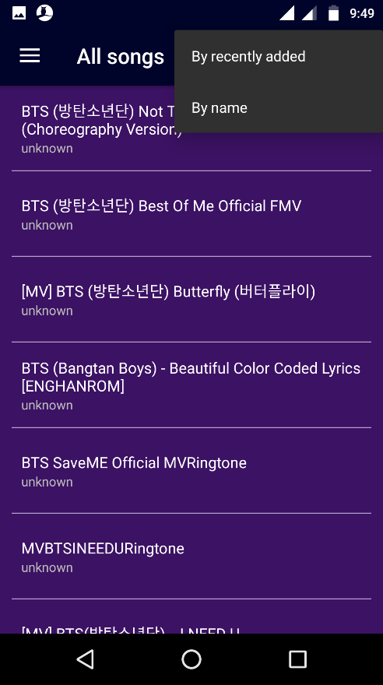

***‘Favorites’ screen***

The ‘Favorites’ screen resembles the ‘All songs’ screen. It will display all the tracks that have

been marked favorite by the user. The user would be able to mark a track favorite or

unfavorite it only on the ‘Now playing’ screen. Ensure that if the user marks a track favorite

and then later deletes it from the offline storage, the track shouldn’t appear on the ‘Favorites’

screen.

If the user has no favorite tracks, there would be a message in the center on the screen

saying, “You haven’t got any favorites yet!”.

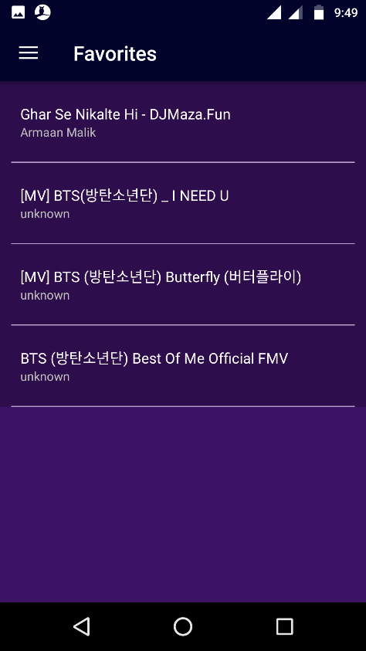 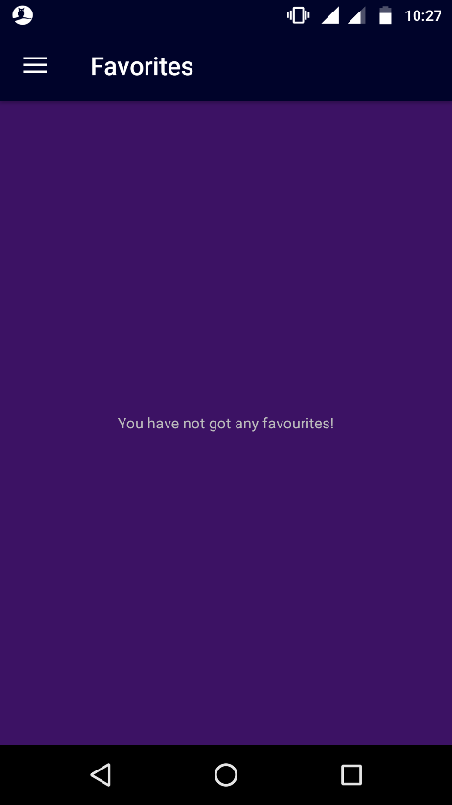

***‘Settings’ screen***

The ‘Settings’ screen will have the option to enable or disable ‘Shake to change song’

feature using the toggle button. The default state of ‘Shake to change song’ feature would be

‘disabled’. If the user enables the ‘Shake to change song’ feature, the app should remember

it, so when the user kills the app and launches it again, the ‘Shake to change song’ should

stay enabled.

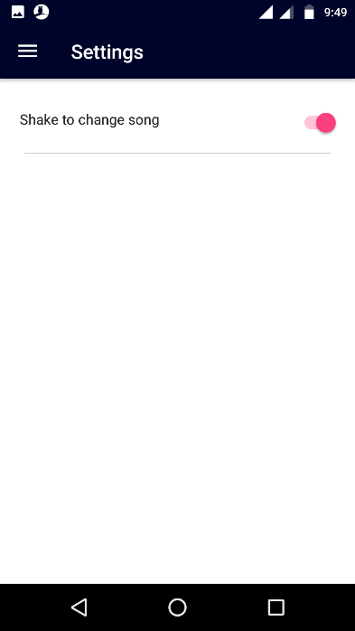

***‘About us’ screen***

The ‘About us’ screen will display the information about the app developer and the app

version. As part of the app developer information, there would developer’s photograph and a

few lines about him/her.

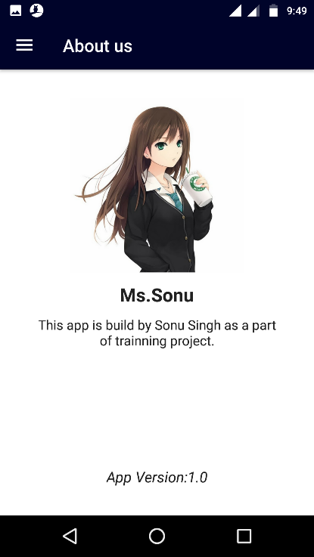

***‘Now playing’ screen***

The ‘Now playing’ screen is the actual music player in the app. It houses all the elements

which let the user interact with the current playing track or the next/previous track. It will

open when the user clicks on a track on the ‘All songs’ screen or the ‘Favorites’ screen. It

would have following features and functionalities:

1. **Track title and track artist**

The track title and track artist would be displayed in the center of bottom half of the

screen. If the track has no title, track name will be displayed. If the track has no artist,

‘unknown’ will be displayed in its place. If the track title or name is too long, an ellipsis

will be added to the title or name.

2. **Play/Pause button**

As the names suggest, this button will be used to play or pause a track. When a track

is playing in the app, this button will become Pause button. When a track is paused in

the app, this button will become Play button. When a user clicks on the Pause button,

the track will pause and when the Play button is clicked, the track will start playing

from the same place where it was paused.

3. **Next button**

This button will allow the user to play the next track. When the Next button is clicked,

the consecutive track in the list (from which the ‘Now playing’ screen was triggered)

will start playing.

4. **Previous button**

This button will allow the user to play the previous track. When the Previous button is

clicked, the consecutive track in the list (from which the ‘Now playing’ screen was

triggered) will start playing.

5. **Shuffle button**

The default state of Shuffle button would be ‘switched off’ (white). When the Shuffle

button is toggled (switched on) by the user, the button would turn yellow indicating

that Shuffle feature has been turned on. When the Shuffle feature is on, the player

would randomly choose a track (different from the one currently playing) from the list

(from which the ‘Now playing’ screen was triggered) and play it when the next button

is clicked or when the current track ends. When the Shuffle button is toggled again

(switched off), the button would again turn white indicating that Shuffle feature has

been turned off. When Shuffle feature is white or switched off, the player would play

the consecutive track in the list when the next button is clicked or when the current

track ends.

If the user switches the Shuffle feature on, the app should remember it, so when the

user kills the app and launches it again, the Shuffle feature stays on.

If the Shuffle feature is on and the Loop feature is turned on, Shuffle feature would

move back to its default state.

The Shuffle feature and the Loop feature can’t be in ‘switched on’ (yellow) state

simultaneously.

6. **Loop button**

The default state of the Loop button would be ‘switched off’ (white). When the Loop

button is toggled (switched on) by the user, the button would turn yellow indicating

that Loop feature has been turned on. When the loop feature is on, the player would

play the same track again when the track ends. The loop button won’t affect the

behaviour of Next button. When the Loop button is toggled again (switched off), the

button would again turn white indicating that Loop feature has been turned off.

If the user switches the Loop feature on, the app should remember it, so when the

user kills the app and launches it again, the Loop feature stays on.

If the Loop feature is on and the Shuffle feature is turned on, Loop feature would

move back to its default state.

The Loop feature and the Shuffle feature can’t be in ‘switched on’ (yellow) state

simultaneously.

7. **Seek bar**

This screen features a *seek-bar* which displays the track progress throughout the

track’s lifetime.A user can click on the seekbar to skip in between the track or simply

to drag the controller to reach a certain part of the track.

8. **‘Mark as favourite’ button**

Clicking this button adds the current track to the favorites list, the button then turns

red indicating that the track has been added to the favorites list. A toast message is

displayed on the screen saying “Added to favorites”.

Clicking this button again will remove the track from the favourites list, the button then

turns back to white indicating that the track has been removed from the favorites list.

A toast message is displayed on the screen saying “Removed from favorites”.

The default state of the ‘Mark as favorite’ button is white, that means, initially there

would be no tracks in the favorites list.

9. **Third party visualiser**

The ‘Now playing’ screen would have a 4 bar visualiser in the upper half of the

screen. As expected, the visualiser would move in the rhythm of the music. The

visualiser’s motion would be volume sensitive meaning that if you turn down the

volume, the visualiser will also tone down its motion and vice-versa. The visualiser

should start moving once a track is played and should stop moving when a track is

paused.

10. **‘Back to list’ button**

The ‘Back to list’ button would take the user to the screen he came from. For ex: if a

user clicked on a track on the ‘All songs’ screen and lands on the ‘Now playing’

screen, the ‘Back to list’ button should take the user back to the ‘All songs’ screen.

This button would be placed in the right side of the header.

11. **Shake to change song**

As the name suggests, this feature would allow the user to change the track just by

shaking his/her phone. We would use the accelerometer on the mobile phones to

make this feature work.

**Now playing screen (track playing)**

**Now playing screen (track paused)**

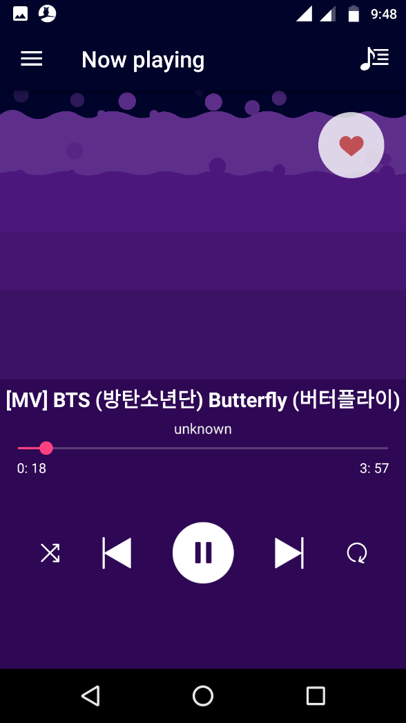

Add to Favorite Button

**Resources:**

Visualiser hex color codes (top to bottom): #270d36, #4e1741, #74204d, #9d2a58

Background hex color code: #00032a

‘Back to List’ icon: back to list

Circle for ‘Mark as Favorite’: white circle

Filled heart for ‘Mark as Favorite’: favorite on

Unfilled heart for ‘Mark as Favorite’: favorite off

Play button: play icon

Pause button: pause icon

Next button: play next

Previous button: play previous

Shuffle white: shuffle white

Shuffle yellow: shuffle

Loop white: loop white

Loop yellow: loop

***‘Now playing’ bar***

The ‘All songs’ screen and the ‘Favorites’ screen will have a ‘Now playing’ bar at the bottom

if the app is playing a track. This bar would display the title of the track playing and play or

pause feature. It would also have an image of some equaliser bars in the left side and a

static text above the track title name saying “Now playing”. If the track title is too long to be

displayed in one line, an ellipsis would appear in the track title. The Play/Pause button would

work same as it did on the ‘Now playing’ screen.

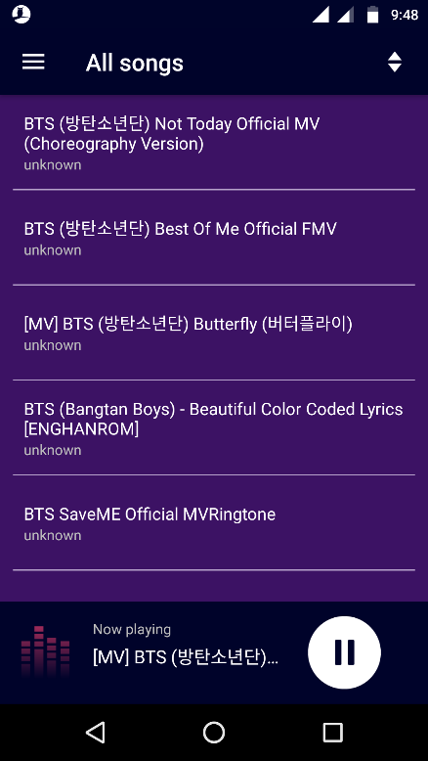

***Background play feature***

Just like any other music player app, this app will allow the user to listen to music even when

the app is running in the background (when a user plays a track in the app and switches to a

different app from notification bar or recent apps section or simply goes to the home screen,

the app will keep running in the background and keep playing the track.)

If there is an incoming/outgoing call while the app is playing a track, the app should pause

the track. As it is a basic music player, the app wouldn’t pause a track for any other case. It

means that if user starts another music player or video player or any such app while our app

is playing a track in the background, our app wouldn’t pause the track and the other app can

play music over our app.

***Notification***

With the background play feature in the app, the user can play tracks in the background, but

he would have no way to figure out which app is playing the track (except for opening and

checking all the recent apps). So the app needs to have a notification indicating that this

particular app is playing music in the background.

The notification would say “A track is playing in the background”. This notification would pop

up in the notifications drawer every time the app plays any track in the background. Ensure

that this notification shouldn’t in the notifications drawer when the app is not playing a track

in the background.

Also, the notification would be there only when the app is playing a track in the background

and it won’t be there when the user is interacting with the app (i.e. if he/she is on any of the

screens of the app).